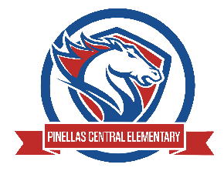

Pinellas Central Elementary School
5th Grade School Supply List 2025-2026

Abby Cannata, Principal Stephanie Wager, Asst. Principal
- 5 composition books (Reading, Writing, Math (2), and Homework)
- plastic (not paper) 2 pocket folder with prongs in the middle for data folder
- 1 spiral notebook for science
- 4 Folders with Pockets (Reading, Writing, Math, Science)
- cloth Pencil pouch (no pencil boxes)
- highlighter
- colored pencils (12)
- chunk eraser
- wood pencils (no mechanical pencils)
- pen
- 1 pair of headphones or earbuds(no bluetooth)

